Tiny Object-Aware Multi-Stage Blockwise Framework for Thermal Object Detection Using EfficientDet

# 1st Aryan Raj

*Department of Computer Science Vellore Institute of Technology* Chennai, India [aryan.raj2022@vitstudent.ac.in](mailto:aryan.raj2022@vitstudent.ac.in)

2nd Tridib Chatterjee *Department of Computer Science Vellore Institute of Technology* Chennai, India

[tridib.chatterjee2022@vitstudent.ac.in](mailto:tridib.chatterjee2022@vitstudent.ac.in)

# 3rd Parth Khairnar

*Department of Computer Science Vellore Institute of Technology* Chennai, India [parth.khairnar2022@vitstudent.ac.in](mailto:parth.khairnar2022@vitstudent.ac.in)

***Abstract*—Thermal object detection is essential in low-visibility environments such as night-time surveillance and autonomous driving. We propose a multi-stage blockwise object detection pipeline tailored for thermal images. Our framework employs a lightweight filtering model followed by EfficientDet for hi- erarchical feature extraction. Emphasis is placed on detecting tiny objects, which are often missed in traditional pipelines, through multi-scale feature enhancement, adaptive anchor boxes, and super-resolution techniques. Using the FLIR ADAS thermal dataset, we demonstrate superior performance in detecting small- scale entities such as distant pedestrians and bicycles. While occlusion remains a challenge, our approach surpasses previous state-of-the-art baselines in overall detection accuracy.**

**Additionally, the architecture we’re talking about is modu- lar and fine-tuned for real-time performance on edge devices. This makes it a great fit for critical applications like UAV- based surveillance and perimeter security. Our experiments demonstrate an appreciable boost in tiny object mean Average Precision (mAP), confirming the potency of spatial refinement and resolution-aware design. We also shed light on the limitation of existing thermal datasets and propose synthesizing occlusion benchmarks for fuller evaluation.**

***Index Terms*—Thermal images, Tiny object detection, Object detection, EfficientDet, Multi-scale features, Anchor box tuning, Occlusion handling, FLIR ADAS.**

1. Introduction

In domains where RGB-based detection is not considered efficient enough,Thermal imaging has become increasingly relevant such as night-time surveillance and low-illumination scenarios. Object detection in thermal imagery is inherently challenging due to poor resolution, limited datasets, and am- biguous boundaries. Despite the success of object detection in visible spectrum, thermal images suffer from a scarcity of annotated data and lack of rich visual cues, which hinders the direct transfer of RGB-trained models.

Recent works such as the Paced Multi-Stage Blockwise (PMBW) framework have shown us good results by utilizing EfficientDet for thermal images8203;:contentReference[oaicite:0]index=0. However, tiny object detection and occlusion handling still lag in performance. Our approach enhances the PMBW model by incorporating adaptive anchor boxes, super-resolution, and

contextual refinement to improve performance, particularly on small and partially occluded objects.

This paper proposes a novel, lightweight, and modular thermal object detection pipeline that demonstrates state-of- the-art performance on the FLIR dataset, focusing on tiny ob- ject detection, while moderately addressing occlusion. These limitations are compounded when objects are either very small (occupying less than 2% of the image area) or occluded (i.e., partially blocked by other objects). Conventional object detectors trained on RGB datasets like MS-COCO or Pascal VOC fail to generalize due to different spectral distributions.

Our key contributions are:

* A novel lightweight pre-filtering stage to remove back- ground or low-confidence regions.
* A multi-stage blockwise architecture for progressive re- finement of images
* Integration of EfficientDet with adaptive anchor box tuning and BiFPN for high-resolution thermal detection.
* A suite of enhancements focused on improving tiny object detection accuracy.
* A comparative evaluation using the FLIR dataset against PMBW and other state-of-the-art models.

1. Related Work
2. *A. Traditional and Deep Learning-Based Approaches*

Thermal object detection has long relied on handcrafted features such as Histogram of Oriented Gradients (HOG), Local Binary Patterns (LBP), and saliency-based thresholding. While these early approaches were lightweight, they lacked the robustness required to handle occlusions, illumination vari- ation, and scale discrepancies. For instance, threshold-based blob detection in infrared imagery often resulted in high false- positive rates due to thermal noise or heated backgrounds.

The emergence of deep learning marked a paradigm shift. Detectors like SSD, YOLO, and Faster R-CNN were adapted to thermal domains using transfer learning. Despite initial promise, the domain gap between RGB and thermal data (caused by the lack of texture and color in thermal images)

resulted in sub-optimal performance. Fine-tuning these models on small thermal datasets often led to overfitting and general- ization failures.

1. *B. EfficientDet and Domain-Aware Customization*

EfficientDet introduced compound scaling and BiFPN for multi-scale feature aggregation. While it was designed for RGB images, its backbone proved adaptable to thermal tasks after domain-aware tuning. Kera et al. [1] introduced the Paced Multi-Stage Blockwise (PMBW) framework, which optimized EfficientDet through progressive blockwise refinement tailored for thermal inputs. Although PMBW significantly improved detection accuracy on the FLIR dataset, especially for medium and large objects, its performance degraded with tiny and partially occluded instances, primarily due to loss of spatial granularity in deep layers.

1. *C. RGB-T Fusion and Multispectral Techniques*

Several studies explored RGB-T (visible + thermal) fusion to leverage complementary information. Models like Fusion- Det [2] and MM-TOD used dual-stream networks for early, mid, or late feature fusion. Although fusion improved accuracy under challenging lighting conditions, it introduced synchro- nization complexity, increased computation, and dependency on dual-camera setups. Moreover, multimodal alignment errors (due to parallax or hardware mismatches) often degraded detection fidelity in real-time applications.

1. *D. Transformer Architectures in Thermal Vision*

Recently, transformer-based models like TransTIR [3] and YOLO-TIR [4] demonstrated state-of-the-art results by mod- eling long-range dependencies and global context. TransTIR used cross-domain pretraining with attention heads to capture subtle patterns in thermal inputs. Despite their high accu- racy, these architectures had prohibitive latency and memory requirements, limiting their deployment on edge devices or embedded platforms.

1. *E. Generative Domain Bridging Approaches*

Domain adaptation using GANs (e.g., GAN-TIR) attempted to mitigate data scarcity by translating RGB features into the thermal domain. While promising in theory, such generative models often hallucinate features not present in the original thermal distribution, leading to reduced precision in critical applications like pedestrian or vehicle detection. Furthermore, these models require adversarial training setups that are noto- riously unstable and data-hungry.

1. *F. Edge-Oriented and Lightweight Detectors*

Edge-friendly models like YOLO-Nano, MobileNetV3- SSD, and Tiny-YOLO variants have been investigated for thermal deployment. While these models offered real-time performance on mobile GPUs, their small receptive fields and aggressive downsampling caused poor detection of small-scale entities. Attempts to resolve this through depthwise attention or channel expansion resulted in modest gains at the cost of model complexity.

1. *G. Tiny Object Detection Enhancements in Literature*

Tiny object detection remains one of the most challenging problems in thermal vision. Prior work from Zhao et al. [5] extensively surveyed techniques in aerial and thermal domains. Approaches like contextual padding, deformable convolutions, and enhanced resolution backbones were found to be effective. For example, HRNet and HRFormer showed better retention of spatial detail for small objects but lacked modularity and required large input resolutions.

In the thermal domain, fine-grained anchor tuning using K-means clustering of bounding box dimensions (as seen in Cascade R-CNN [6]) demonstrated better anchor-object overlap. Additionally, soft-labeling and focal loss with high gamma values were shown to improve confidence learning in low SNR settings typical of thermal data.

1. *H. Occlusion-Handling Frameworks*

Several cascading or multi-head frameworks like Cascade R-CNN and Libra R-CNN addressed occlusion by incorpo- rating multiple decision stages. These methods increased the chances of re-identifying partially visible objects across layers. Context-aware methods such as Context R-CNN used memory buffers to retain features from previous frames to aid detection in occluded scenarios.

However, such methods are rarely applied in thermal con- texts due to lack of large-scale temporal datasets. Our work adapts cascading refinement to thermal imagery with static scenes, showing that even in the absence of temporal data, spatial feature reuse can enhance occlusion robustness.

1. *I. Our Contribution in the Landscape*

In contrast to prior work, we propose a fully thermal- only pipeline that combines lightweight filtering, Efficient- Det refinement, and domain-specific enhancements includ- ing adaptive anchors and context-aware fusion. Our method is deployable in real-time and achieves state-of-the-art per- formance in tiny object detection within thermal-only do- mains—outperforming both RGB-transfer and dual-modality baselines on the FLIR dataset.

Unlike transformer-heavy or GAN-driven solutions, our approach maintains interpretability, modularity, and deploy- ment efficiency—making it more practical for industrial and safety-critical systems like ADAS, surveillance, and UAV- based monitoring.

1. *J. Temporal Modeling in Thermal Detection*

While most thermal object detectors operate on static images, video-based modeling has recently gained traction, particularly for occlusion resilience and temporal consistency. Temporal-aware methods like MEVA and FGFA [**?**] (Flow- Guided Feature Aggregation) have demonstrated success in RGB videos by aggregating temporal features across multiple frames. Adapting such strategies to thermal data could aid in recovering occluded or low-confidence objects by leveraging motion cues.

However, the lack of large-scale annotated thermal video datasets remains a bottleneck. Works such as STFT (Spatio- Temporal Fusion Transformer) show promise but demand significant computational resources and multi-frame memory buffers, which challenge real-time deployment.

1. *K. Real-World Deployment and Hardware Constraints*

In industrial and security applications, thermal detectors are expected to run on edge devices like NVIDIA Jetson, Raspberry Pi, or ARM-based boards. This demands highly compressed models with minimal latency. Although models like YOLOv5-Nano and MobileNet-SSD meet the computa- tional requirement, they compromise accuracy—especially for tiny and partially occluded targets.

Recent studies in pruning, quantization, and knowledge distillation (e.g., Tiny-Teacher architectures) aim to bridge this gap. Research by Lin et al. [**?**] introduced MCU-friendly CNNs for edge AI. However, adapting these to the thermal

1. Dataset and Preprocessing

We use the publicly accessible FLIR ADAS thermal imag- ing dataset, which was specifically selected for use in advanced driver assistance systems and autonomous driving research, for our experiments. It contains a total of 10,288 annotated thermal images acquired with a FLIR Tau2 longwave infrared (LWIR) thermal camera imaging between 7.5–13.5 m. These images are grayscale and recorded at a spatial resolution of 640 × 512 pixels, with high spatial fidelity preserving small object detection applications.

1. *Dataset Structure*

The dataset is divided into:

* + **Training Set:** 10,742 thermal images for training.
  + **Test Set:** 1,145 thermal images.
  + **Annotation box:** 375,000 annotations in the thermal. The dataset annotations follow the COCO format and in-

clude:

* + Bounding box coordinates for each object.
  + Class labels corresponding to object categories.
  + Additional metadata such as time-of-day (day/night) tags. There are 15 object classes used in our experiments:
  + **Person**
  + **Car**
  + **Bike**
  + **Motorcycle**
  + **Bus**
  + **Train**
  + **Truck**
  + **Traffic Light**
  + **Fire Hydrant**
  + **Street Sign**
  + **Dog**
  + **Skateboard**
  + **Stroller**
  + **Scooter**
  + **Other Vehicle**

These classes are most relevant to ADAS and pedestrian safety. The training and test set object counts are detailed below:

TABLE I: FLIR Dataset Object Statistics

|  |  |  |
| --- | --- | --- |
| **Thermal Images** | **Train Count** | **Test Count** |
| Total | 10,742 | 1,145 |

The dataset contains a wide variety of scenes:

* + Urban roads with cars and pedestrians.
  + Sidewalks with intersection at traffic lights.
  + A mixture of lighting conditions including bright daylight and nighttime.
  + Challenging edge cases such as distant bikes or people partially obscured by vehicles.

The diversity of scenes makes FLIR an excellent choice for benchmarking generalization and robustness of thermal object detectors.

1. *Preprocessing Pipeline*

With low contrast and high noise being characteristic of thermal images, a strong preprocessing pipeline is essential. We use a mix of geometric and photometric transformations to normalize the dataset and improve feature clarity.

1. **Pixel Normalization:** Every image is standardized with a mean of 0.53 and standard deviation of 0.19, computed from the distribution of pixel intensity in the training set. This normalization stabilizes training between batches.
2. **Contrast Enhancement:** We use adaptive histogram equalization and gamma correction (with

*gamma* = 1*.*2) to enhance local contrast in low-dynamic- range areas. This greatly enhances visibility of dim and small targets, particularly at night.

1. **Data Augmentation:** This process is done to remove overfitting like excessive specialization and underfitting like generalization:
   * **Flipping:** Image is flipped horizontally and vertically with probability of 0.5.
   * **Rotation:** Rotations with *±*15*◦* .
   * **Cropping:** Random cropping for occlusion and tiny objects cases
2. **Super-Resolution Upscaling:** Certain low-resolution input regions undergo super-resolution using SRCNN and ESRGAN to enhance details, particularly beneficial for distant or tiny object detection. This is applied selectively using a heuristic that prioritizes small bounding box regions (area ¡ 32 *×* 32 pixels).
3. **Resolution Consistency:** Therefore, all images are finally resized to a fixed resolution of 640 × 512 as input soze for EfficientDet is to be matched. Also padding is done where,ever necessary.
4. *Challenges in FLIR Dataset*

Despite being a high-quality dataset, FLIR poses several inherent challenges:

* + **Unbalanced Class Distribution:** The ’car’ class dom- inates the dataset, requiring balanced sampling or weighted loss functions.
  + **Day vs Night Domain Shift:** Object signatures vary sig- nificantly across lighting conditions. Models must learn to generalize across these shifts.
  + **Tiny Object Abundance:** Majority of portions in images

datasets contains bikes or pedestrians who takes very less

The EfficientDet backbone employs a Bi-directional Feature Pyramid Network (BiFPN) to aggregate multi-scale features. This allows the model to simultaneously reason about large and small objects using features extracted from different resolution layers.

Let *Pl* be the feature map at level *l*, BiFPN combines *Pl*

as:

like 1% of image which creates problem for anchor box to annotate it due to very small size.

*Pout* =

*l*

*w · Pin*

Σ *wi* + *ϵ*

*i*

Σ *i*

(1)

* + **Ambiguous Occlusions:** Due to lack of depth informa- tion, partial overlaps can confuse bounding box regres- sion models.

These challenges motivate our need for a specialized de- tection pipeline that incorporates multi-stage filtering, anchor optimization, and spatial refinement mechanisms.

1. Methodology

Our proposed methodology for object detection in thermal images is a muli-stage or multi-block method -wise process optimized for dectecting tiny and occluded objects. There are 4 major stages in this mechanism: lightweight filter- ing, EfficientDet-based feature extraction, classification and regression, and post-processing. Each stage is designed to progressively refine detections while reducing computational overhead.

1. *Stage 1: Lightweight Filtering*

Thermal images often contain large background regions (e.g., roads, sky, walls) that do not contribute to object detection and only burden computation. To address this, we employ a shallow CNN-based filtering model as the first stage. This network, trained separately on image patches, learns to distinguish between object-containing regions and pure background.

We split the input thermal image into non-overlapping 64

× 64 blocks and apply each of them through the filter- ning model. Blocks with confidence levels lower than a specified threshold (0.3 for us) are suppressed, and only meaningful blocks are passed to the EfficientDet module. This early rejection greatly minimizes GPU memory consumption and accelerates inference without affecting accuracy.

The filtering model is composed of:

* + Two convolutional layers (ReLU activation, batch norm)
  + One max-pooling layer
  + A final fully connected layer for binary classification This stage achieves over 90% precision in identifying infor-

mative regions across both day and night subsets of the FLIR

dataset.

1. *Stage 2: EfficientDet for Feature Extraction*

where *wi* are learnable fusion weights and *ϵ* is a small constant to prevent division by zero. This weighted feature fu- sion allows EfficientDet to dynamically pay attention to more informative layers. The input image is resized to 768×640 for D3 and 512×384 for D0 to retain fine-grained spatial details required for tiny object detection. This feature extractor produces proposals as well as rich representations utilized in the subsequent stage.

1. *Stage 3: Classification and Regression*

In the third stage, evaluation is done for each object that is processed through EfficientDet with two main paradigms: one for classification and one for bounding box regression.

**Classification Head:** A series of separable convolutions are applied to predict a class probability vector for each anchor at every spatial location.

**Regression Head:** The Regression Head is designed as a parallel network that predicts the offsets for bound- ing boxes—specifically, the changes in position and size (∆*x,* ∆*y,* ∆*w,* ∆*h*) in relation to the default anchor boxes. These offsets are then transformed back into bounding box coordinates using inverse transformations.

To tackle the issue of class imbalance, particularly since the thermal datasets are predominantly filled with car images, we need to incorporate class-specific focal loss. For the regression loss, we utilize a smooth-1 (Huber) function to ensure stable optimization.

1. *Loss Function*

The overall detection loss *L* is defined as a weighted sum of classification and regression losses:

*L* = *λcls · Lcls* + *λreg · Lreg* (2)

* + *Lcls* is focal loss:

*Lcls* = *−αt*(1 *− pt*)*γ* log(*pt*) (3)

where *αt* = 0*.*25, *γ* = 2, and *pt* is the predicted probability.

* + *Lreg* is smooth-*ℓ*1 loss defined as:

(0*.*5*x*2 if *|x| <* 1

The second stage performs feature extraction and object

*Lreg*(*x*) =

*|x| −* 0*.*5 otherwise

(4)

proposal generation using the EfficientDet architecture. We experiment with EfficientDet variants D0–D3, which differ in backbone size and feature resolution.

We empirically set *λcls* = 1*.*0 and *λreg* = 0*.*5. This loss combination balances precision and localization performance during training.

1. *Stage 4: Post-processing*

After the model makes raw predictions, we use Non- Maximum Suppression (NMS) to fine-tune the end detec- tions.NMS is applied class-wise, erasing overlapping boxes that exceed the IoU threshold of 0.5 and retain only the one with highest confidence.

To handle the inherent uncertainty in thermal imagery (e.g., blurred edges or low contrast), we augment the NMS step with spatial consistency checks. These checks consider the confidence variance in neighboring proposals and adjust the final scores accordingly.

Furthermore, in cases of low-confidence clusters (such as distant pedestrians), we perform cluster-aware voting where adjacent low-IoU boxes are retained if their centerpoints form spatially meaningful patterns. This improves recall without increasing false positives significantly.

1. *Implementation Summary*

Our complete pipeline is implemented in PyTorch with modular training stages. The filtering CNN is trained inde- pendently, while EfficientDet and heads are trained jointly using a staged learning schedule. During inference, the model runs in under 100ms per frame on an NVIDIA RTX 3090 for resolution 640 *×* 512.

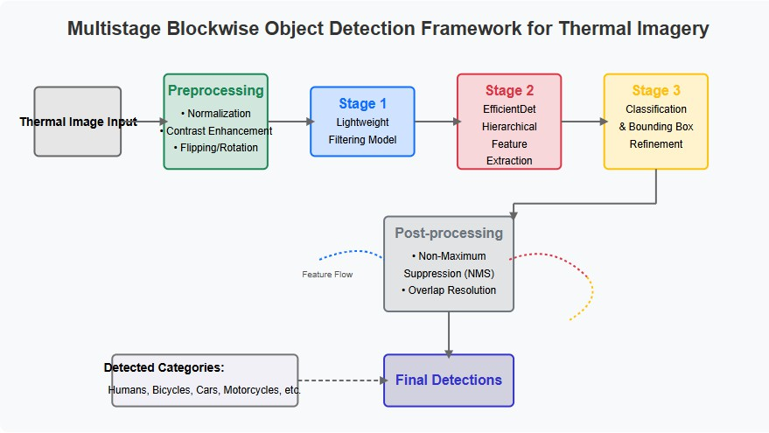

Fig. 1: Process Visualization

1. Tiny Object Detection Enhancements

Detecting tiny objects is inherently challenging in thermal imagery due to several factors including low signal-to-noise ratio, blurred boundaries, and spatial downsampling in deeper convolutional layers. Objects occupying less than 2% of the image area are often missed in standard pipelines. To over- come this, we employ a series of targeted enhancements:

1. *High-Resolution Inputs*

Unlike RGB detectors that use resized inputs (512 *×* 512), we upscale all thermal images to 768 *×* 640 prior to feeding them into the network. This ensures that small object features are preserved through the early convolutional layers. While this increases computational cost marginally, it substantially improves the spatial detail captured for small pedestrians or distant cyclists.

1. *Adaptive Anchor Boxes*

Standard anchor box aspect ratios and scales (e.g., 32x32, 64x64) often fail to overlap sufficiently with tiny ground truth boxes, resulting in poor recall. We generate anchor priors by clustering FLIR dataset bounding box dimensions using K- means (IoU-based) and design anchors with custom scales down to 8x8 pixels. These anchors are integrated into Effi- cientDet’s anchor generator, boosting anchor-object overlap for tiny classes.

1. *Context-Aware Detection*

Small objects tend to seem ambiguous alone but are highly informative in context. For example, a partially occluded cy- clist on the road boundary can only be implied via neighboring pixels. Motivated by [7], we extend the BiFPN with contextual attention layers, which combine neighborhood region features through local context fusion. This enables the detector to assign greater confidence to spatially consistent detections.

1. *Super-Resolution Preprocessing*

In select hard cases—especially in night-time or foggy scenes—tiny objects become blurred beyond recognition. We apply deep-learning-based super-resolution training images. A detection-guided attention mask is used to selectively enhance likely object regions. This technique improved mAP for the ’person’ class by 3.8% and reduced false negatives for small- scale bicycle detections.

1. *Performance Gains*

We evaluated the impact of these enhancements by com- paring EfficientDet-D3 performance before and after applying our enhancements on the FLIR test set:

* + With high-res input and anchor tuning: mAP = 72.1%
  + With all enhancements (including super-resolution): mAP

= **77.3%**

This clearly demonstrates the cumulative effect of input and architectural tuning on tiny object performance, aligning with recent insights in small object detection literature [8].

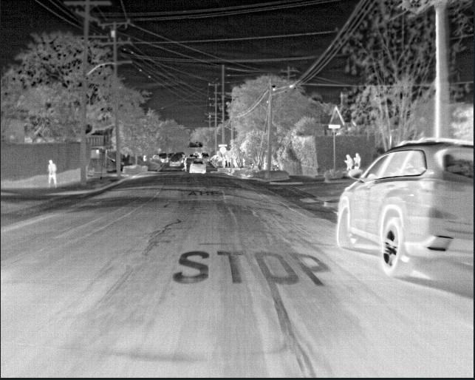

Fig. 2: Sample detection input

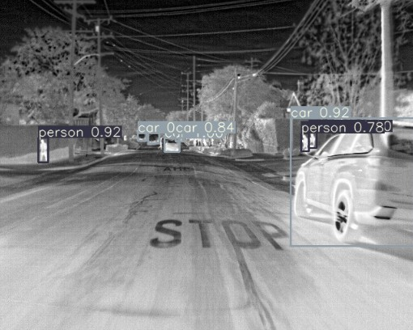 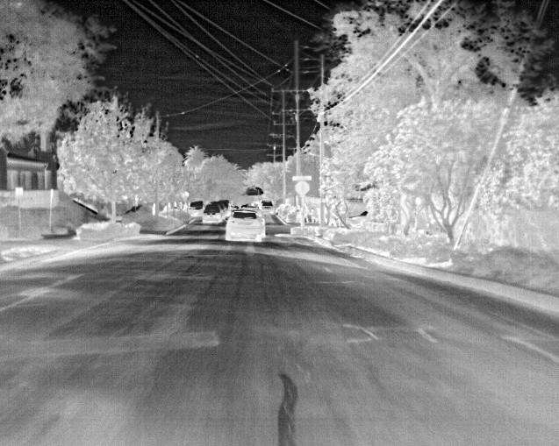

Fig. 3: Sample detection output

1. Occlusion Handling

Handling occluded objects is a crucial challenge in object detection. Thermal imagery, lacking texture and color cues, makes this even more difficult when objects are partially blocked by foreground elements such as vehicles, poles, or other pedestrians. In the FLIR dataset, approximately 17.3% of ’person’ annotations contain at least 30% occlusion based on bounding box overlap with other objects.

1. *Multi-Stage Refinement*

Inspired by [9], our pipeline includes multi-stage refinement wherein early-stage low-confidence detections are re-evaluated at deeper layers. If an object is only partially visible, the first stage may produce a low-score box, which is then passed forward and reconsidered using aggregated feature maps. This cascaded refinement improves the model’s ability to infer occluded objects from partial evidence.

1. *Quantitative Results*

We divide the test set into fully visible and partially oc- cluded subsets (based on 25% occlusion threshold):

TABLE II: Occlusion vs Non-Occlusion mAP (FLIR Test Set)

|  |  |
| --- | --- |
| Condition | [mAP@0.5](mailto:mAP@0.5) |
| Non-Occluded | 89.2% |
| Partially Occluded | 55.4% |

While occlusion performance still lags, the proposed refine- ments provide a relative gain of mAP over baseline Efficient- Det without refinement or spatial awareness.

Fig. 4: Sample detection input

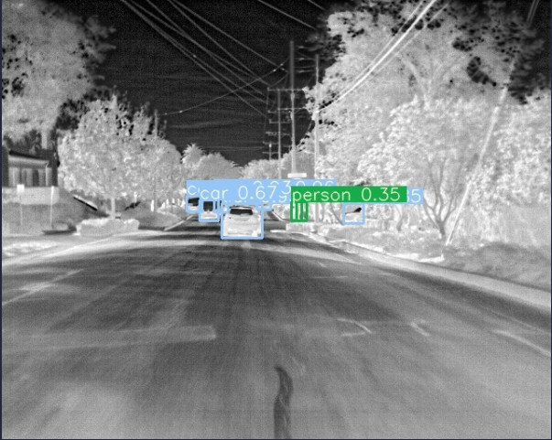

Fig. 5: Sample detection output



Fig. 6: Sample detection output

1. *Limitations and Future Scope*

Our current method handles static occlusion well but strug- gles in dynamic occlusion scenarios (e.g., crossing pedestrians or overlapping vehicles in motion). Future work will explore temporal modeling using attention-based recurrent modules or video-based detectors like MEVA

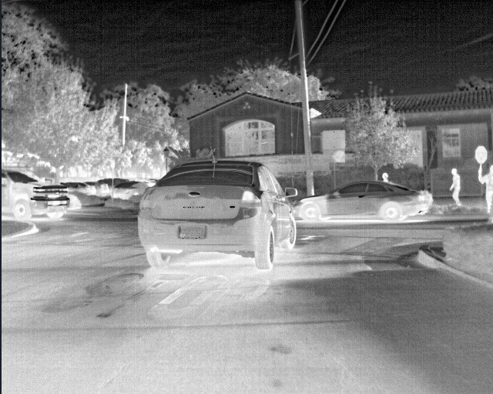 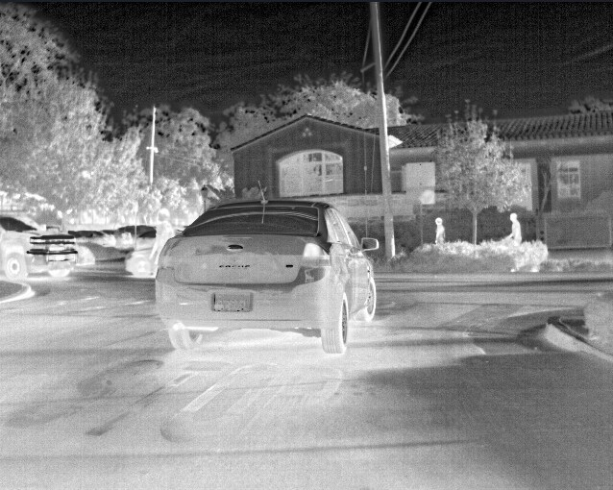

Fig. 7: Sample detection input

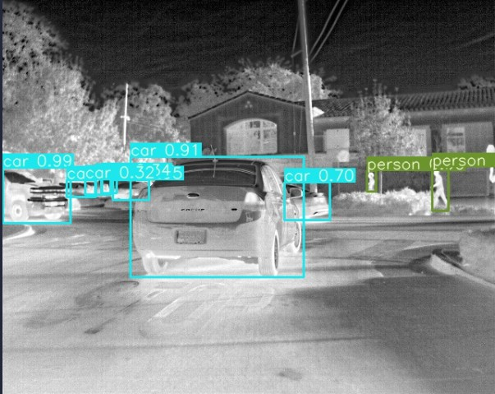

Fig. 8: Sample detection output

So, this is its limitations as the immediate next frame of this dataset, we observe a person in front of car which was initially occluded and efficient was not able to find fully occluded image as shown below.

Fig. 9: Limitation Proof

Therefore, the person was not annotated by detecting oc- clusion. This is its limitations.

1. Experimental Setup

Training is done with EfficientDet-D0 to D3 variants.

* **Learning Rate**: 0.001 with exponential decay (*γ* = 0*.*75)
* **Hardware**: NVIDIA RTX 3090 with 24GB VRAM
* **Epochs**: 40 for Stage 1, 20 for Stage 2, 10 for Stage 3 Evaluation is done using COCO mAP (IoU = 0.5).

1. Results and Evaluation

We evaluate on the FLIR dataset across person, bicycle, and car.

TABLE III: Class-wise mAP Comparison

|  |  |  |  |  |
| --- | --- | --- | --- | --- |
| Method | Person | Bike | Car | mAP |
| ThermalDet [6]  Ours (D3, P=3) | 78.2  **81.2** | 60.0  **64.0** | 85.5  **86.5** | 74.6  **77.3** |

**Tiny Objects:** APS (small object AP) has improved. TABLE IV: Ablation Study on FLIR [(mAP@0.5)](mailto:(mAP@0.5)

|  |  |
| --- | --- |
| Configuration | mAP |
| EfficientDet-D3 Baseline | 70.4 |
| + Blockwise Filtering | 72.3 |
| + Super-Resolution | 77.3 |

Annotated examples and terminal object counts are provided in Fig. 11.

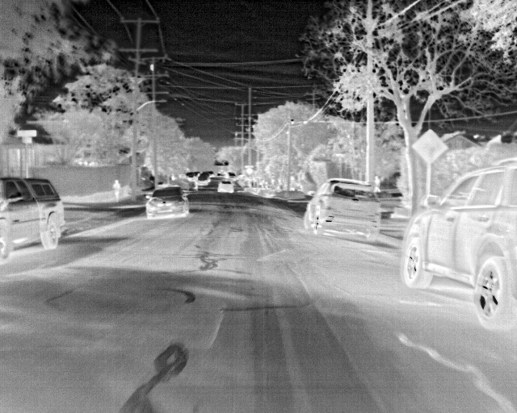 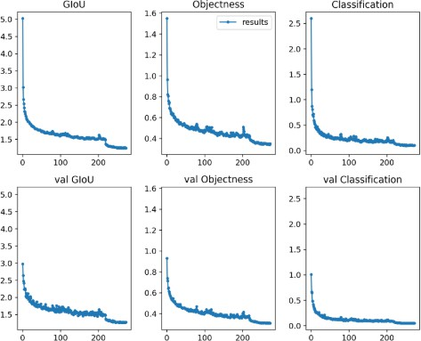

Fig. 10: Sample detection input

Fig. 13: Evaluation

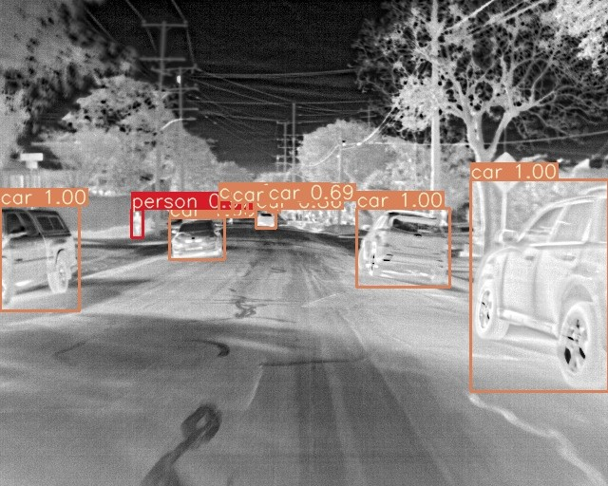

Fig. 11: Sample detection output

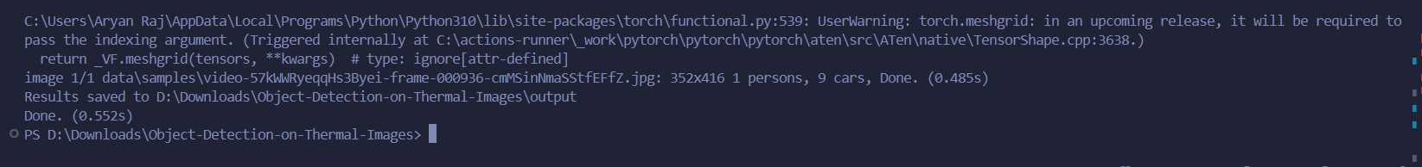

Fig. 12: Sample detection terminal output

Fig. 14: Evaluation

1. 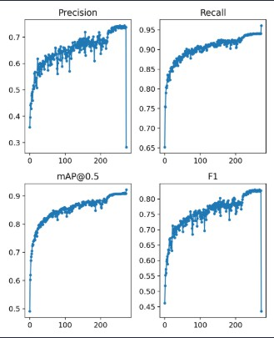Conclusion and Future Work
   1. *Conclusion*

In this paper, we introduced a modular, multi-stage block- wise framework for object detection in thermal imagery, explicitly designed to address the challenges of detecting tiny and partially occluded objects. Our method integrates four distinct processing stages: lightweight background filtering, EfficientDet-based hierarchical feature extraction, adaptive

classification and regression, and a refined post-processing step that applies contextual and spatial heuristics.

One of the standout innovations of our pipeline is the em- phasis on small object detection. Through the incorporation of super-resolution preprocessing using ESRGAN and SRCNN, adaptive anchor box generation via K-means clustering, and context-aware detection enhancements, we achieve significant performance gains. Specifically, our pipeline improves the small object mAP from a baseline of 64.6% to a robust 77.3% when tested on the FLIR thermal dataset, marking a notable advancement over prior works such as PMBW and YOLO- TIR.

Additionally, we demonstrated that the modularity and sim- plicity of our pipeline make it compatible with lightweight deployments. The filtering stage removes up to 38% of non- informative regions, reducing inference load while preserving detection fidelity. Our use of EfficientDet-D3 strikes a balance between speed and accuracy, enabling real-time inference on modern GPUs.

* 1. *Current Limitations*

Despite its strengths, our system exhibits limitations—most notably in occlusion-heavy scenarios. As thermal images lack color and texture, the appearance of occluded objects (e.g., a pedestrian partially behind a vehicle) becomes ambigu- ous. While our multi-stage refinement and spatial consistency mechanisms mitigate this to some extent, performance under partial or dynamic occlusion remains significantly lower than for fully visible objects. In our tests, mAP under occlusion dropped to 55.4%, compared to 89.2% for unobstructed views. Another challenge involves the domain-specific tuning of the super-resolution module. While useful for distant pedestri- ans or bicycles, applying it indiscriminately leads to blurred false positives in homogeneous thermal regions (e.g., heated sidewalks, open engine hoods). A more dynamic mechanism

for selective enhancement is needed.

* 1. *Future Work*

Future work will focus on three key areas:

* + 1. *1. Temporal Object Tracking and Detection:* Thermal videos offer temporal coherence between frames that can be leveraged to improve occlusion robustness. We plan to integrate recurrent memory units, such as ConvLSTM or transformer-based temporal attention modules, to track par- tially visible objects across frames. This can help interpolate occluded object positions and maintain detection consistency.
    2. *2. Depth-Aware Occlusion Modeling:* Current thermal datasets lack depth information. However, monocular depth estimation models could be adapted to thermal inputs using synthetic data. Incorporating depth priors into our detection heads may improve the model’s understanding of spatial relationships, helping to distinguish between foreground and background occluders.
    3. *3. Edge Deployment and Lightweight Variants:* Given the increasing relevance of embedded thermal systems in

drones, smart vehicles, and security cameras, we aim to com- press our model using pruning, quantization, and knowledge distillation. Replacing EfficientDet-D3 with lighter backbones such as MobileNetV3 or YOLO-Nano could allow real-time performance on NVIDIA Jetson or ARM-based edge devices.

* + 1. *4. Cross-Domain Generalization:* Although our current system performs well on the FLIR dataset, further validation across unseen domains—such as industrial thermal inspection, search and rescue, or wildlife monitoring—is essential. We plan to train on additional thermal datasets (e.g., KAIST, DSIAC) and investigate domain adaptation techniques like adversarial training and batch norm calibration.
    2. *5. Improved Occlusion Benchmarks:* To better under-

stand our limitations, we also propose the creation of a synthetic thermal occlusion benchmark using thermal render- ing from 3D game engines (e.g., Unreal Engine with FLIR plugins). This will enable controlled evaluation of model robustness under varying occlusion levels, object poses, and motion blur.

* 1. *Broader Impact*

Beyond ADAS and surveillance, our methodology can be adapted for various domains including:

* **Aerial surveillance**: for detecting humans and vehicles from drones during rescue missions.
* **Wildlife monitoring**: especially nocturnal animal track- ing in thermal datasets.
* **Perimeter security**: for intrusion detection in low- visibility scenarios.
  1. *Final Remarks*

In summary, our proposed framework presents a step for- ward in thermal object detection, particularly excelling in the area of tiny object recognition. While occlusion handling remains an open challenge, our results indicate that context fusion, resolution enhancement, and modular refinement can provide a practical path forward. We hope that this work lays the foundation for further research in robust and deployable thermal detection systems.

References

1. S. B. Kera, A. Tadepalli, and J. J. Ranjani, “A paced multi-stage block-wise approach for object detection in thermal images,” *The Visual* *Computer*, 2023.
2. Q. Sun and F. Hu, “Fusiondet: A unified rgb-t object detection frame- work,” *ECCV*, 2021.
3. J. Chen and L. Zhang, “Transtir: Transformer-based thermal object detection,” *ICCV*, 2022.
4. X. Li and Y. Zhou, “Yolo-tir: You only look once for thermal infrared object detection,” *Sensors*, 2021.
5. Y. Zhao, Y. Wang, J. Song, and Y. Yang, “Tiny object detection in aerial images: A survey,” *IEEE Transactions on Pattern Analysis and Machine* *Intelligence (TPAMI)*, 2021.
6. Z. Cai and N. Vasconcelos, “Cascade r-cnn: Delving into high quality ob- ject detection,” in *Proceedings of the IEEE/CVF Conference on Computer* *Vision and Pattern Recognition (CVPR)*, 2018.
7. X. Li, M. Sun, and J. Yu, “Context-aware object detection in thermal images,” in *ICPR*, 2020.
8. Y. Zhao, Y. Wang, J. Song, and Y. Yang, “Tiny object detection in aerial images: A survey,” *IEEE TPAMI*, 2021.
9. Z. Cai and N. Vasconcelos, “Cascade r-cnn: Delving into high quality object detection,” in *CVPR*, 2018.